Contents

**1.** **Introduction** 1

**2.** **Product Overview** 2

**1.1** **Problem Statement** 2

**1.2** **Product Position Statement** 2

**1.3** **Product scope** 3

**2** **Product team** 3

**3** **Main Features** 3

**Template matching** 3

**Smart ORC:** 4

**Face recognize:** 4

**4** **Innovated Feature** 5

**5** **Road map** 5

**6** **Future plan** 5

1. **Introduction**

* Team’s name: SYNACK
* Context: We are in a competition that developing a mobile application using many techniques of React Native and Data Science to tackle problems from one of five companies that are MoMo, FE Credit, SenDo, Haravan, ChoTot.
* Our choice: Solving the problems of FE Credit company**.**

1. **Product Overview**
   1. **Problem Statement**

|  |  |
| --- | --- |
| The problems of | Face many online frauds from customers such as using fake IDs or using unauthorized information from others to apply for loans online and performance of manual checking for a large amount of ID cards take times, efforts and may cause critical mistakes as well. |
| Affects | FE Credit and companies that offer many products and services over the digital channels as well. |
| The impact of which is | Huge negative impact on the process of their businesses. |
| A successful solution would | These companies can detect fraudulent documents submitted by customers such as National ID and their customers can submit their national id card to the system. |

* 1. **Product Position Statement**

|  |  |
| --- | --- |
| For | FE Credit company as well as others in the same businesses and their customers |
| Who | Companies who want to check the national Id card from customers and Customers who have to submit their national Id card for businesses process. |
| The (Product name) | RealID |
| That | Available for Companies detects a fake national Id card from customers and Customers can submit their national Id card to the company |
| Our product | Develop a mobile application to detect fraudulent documents submitted by customers such as National ID in order to prevent using fake IDs to apply for online businesses process from customers. |

* 1. **Product scope**
* Only detecting fraudulent documents submitted by customers for National ID including three methods:
* Template Matching: Focus on the national badge and the 3x4 picture on it.
* Smart OCR
* Face recognizing

1. **Product team**

|  |  |  |
| --- | --- | --- |
| **Member’s Name** | **Role** | **Contact** |
| Lâm Tuấn Tú | Product Manager | tulam1503@gmail.com |
| Lê Trần Đại Trung | Technical Leader | daile.programer@gmail.com |
| Lê Thanh Tiềm | Data Scientist | thanhtiemqt@gmail.com |
| Nguyễn Chí Thanh | Data Scientist | chithanhnguyen@gmail.com |
| Mai Tiến Nhất | Mobile Developer | locliem08@gmail.com |

1. **Main Features**

## **Template matching**

Based on a template of a static prepared ID card picture, detect either there is the ID card or not, the front side or back side, crop and bounding the national badge and the 3x4 picture on it.

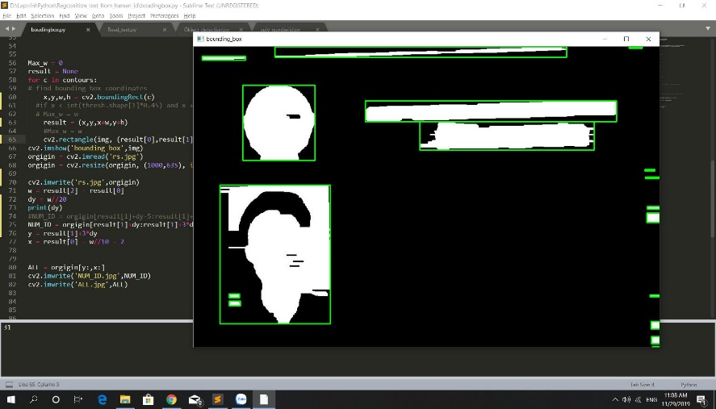

## **Smart ORC:**

Available for taking a real-time picture of a ID card and in case it was not distorted too much, we can auto transform it to the right position and orientation then crop and resize it to the right form and scale. After that, we get the information frames by using a list of position mask and throw the result into many pre-processing function to bring it to the final clear binary image that our OCR model can read correctly.

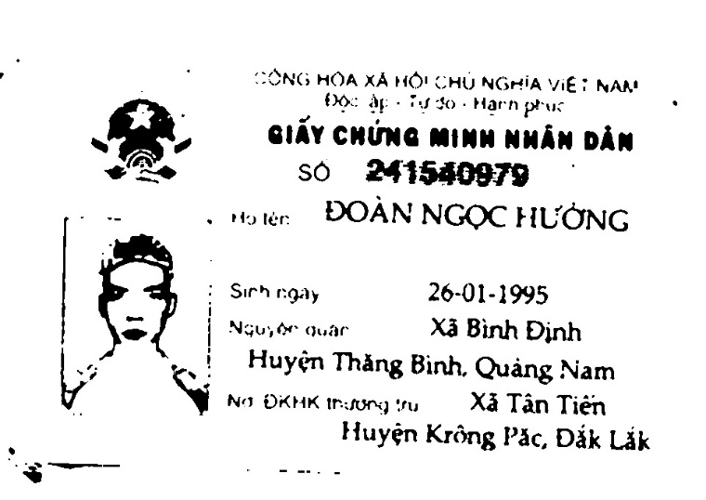

## **Face recognize:**

We crop the 3x4 image out of the ID card and compare it with the selfie picture. We are using deep learning model to detect whether it match or not. We also tried a trick to prevent users to use a printed picture or use a screen to display the image when taking live picture with the front camera. But as we said above, it’s still not 100% reliable.

1. **Innovated Feature**

**Fingerprint module**: Crop out the fingerprint on the backside of the ID card and compare it with the real fingerprint of the applicant using this optical scanner we ordered from abroad.

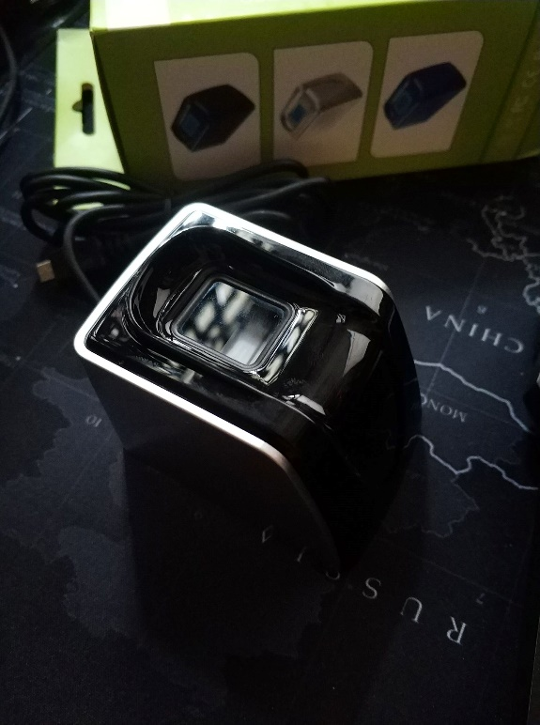

1. **Road map**

* The project is composed of multiple phases as follows:
* Phase 1 – Documents and Solutions Research (1 week)
* Phase 2 – Make a first MVP (2 weeks)
* Phase 3 – Inproving solutions and developing advanced funtions. (2 weeks)
* Phase 4 – Packed the software and make it ready to race. (1 week)
* The main concept of the project includes construction work associated with Phase 2, 3 and 4, which includes installation and testing of both server side and client side

1. **Future plan**

* Extending the number of cards are available for detecting for passports, the driving licence cards.
* Available for checking whole part of cards in term of template matching.
* Improving function of face recognizing when the selfie picture was captured from tilt angle. Detecting each other from twin will be complete.
* Providing a market place about detecting plenty kinds of card for companies who want to detect that cards and customer who want to submit their card to gain personal purposes.